Let me give you a simple example of RxJS and explain how it works. RxJS stands for Reactive Extensions for JavaScript, and it's a library for working with asynchronous events, like clicks, HTTP requests, etc. It makes it easier to handle events like streams of data over time.
We'll start with a basic example where we'll simulate a stream of data and use operators to manipulate that data.

Simple Example:
Imagine you are receiving a stream of numbers and you want to double them and then filter out the numbers that are less than 10.
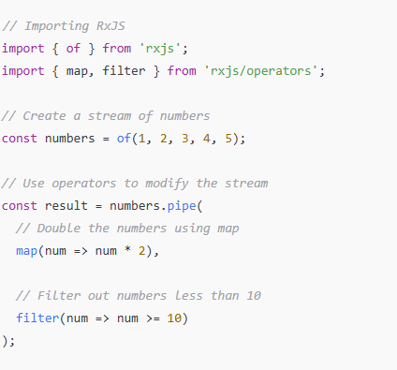
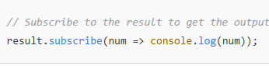

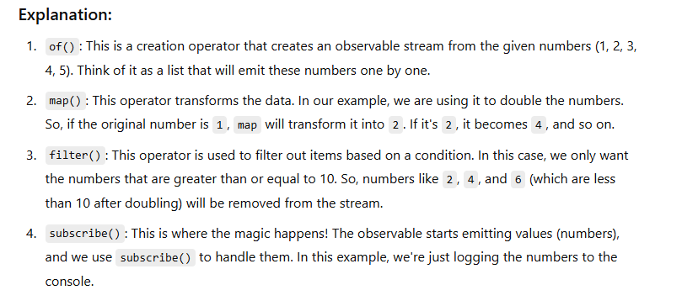

Operators in RxJS:
- map(): Transforms the data by applying a function to each value emitted by the observable.
- filter(): Filters the data based on a condition (keeps only the values that pass the test).
- subscribe(): This is used to listen to the observable and act when data is emitted.

tap(): You can use this operator to perform side effects (like logging) without changing the data. It's great for debugging!

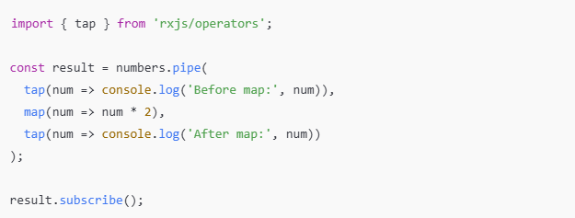
take(): Limits the number of emissions. For example, you can take just the first 2 values from a stream.
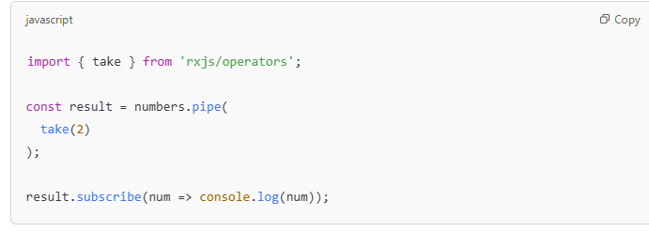

• RxJS is useful for handling data streams.
• Operators like map() and filter() help you manipulate and work with that data.
• subscribe() is how you "listen" to the stream and react to the data.

What Are These Methods?
- next(): Sends the next value to the subscribers.
- complete(): Signals that the observable has finished emitting values, and no more data will be sent.
- error(): Used to send an error to the subscribers. This can be used when something goes wrong in the observable stream.
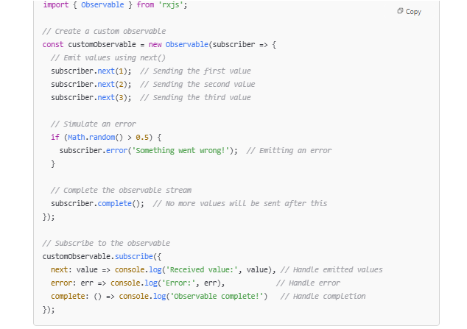

Explanation:
- Creating an Observable:
  - We create a custom observable using new Observable().
  - Inside the observable, we use the subscriber object to emit values to the subscribers.
- Using next():
  - subscriber.next(value) is used to send values to the subscribers. The values are emitted one by one.
- Using error():
  - If an error happens, we can send an error message using subscriber.error('error message').
  - This will stop further emissions and trigger the error callback in subscribe().
- Using complete():
  - subscriber.complete() indicates that the observable has finished emitting values.
  - After calling complete(), no more values will be emitted.
- subscribe():
  - Inside the subscribe() method, we provide three functions:
    - next: Handles each value emitted by the observable.
    - error: Handles any errors that might occur.
    - complete: Handles when the observable has finished emitting all values.

Another Example: Using next(), complete() and Simulating Delayed Values
This example shows how to delay the emission of values:

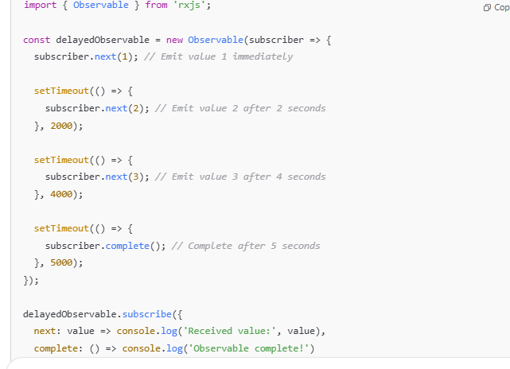
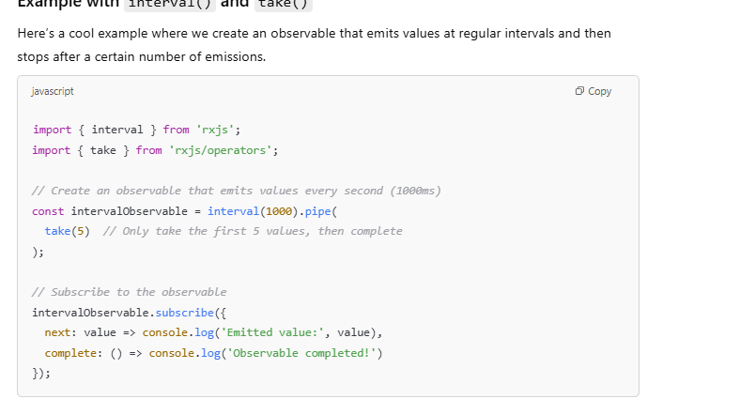
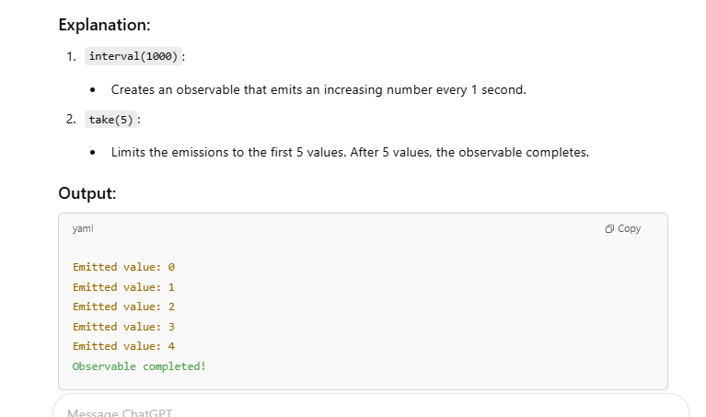

1. map() - Transforming values
The map() operator allows you to transform the values emitted by an observable. It’s similar to the .map() function you use on arrays.
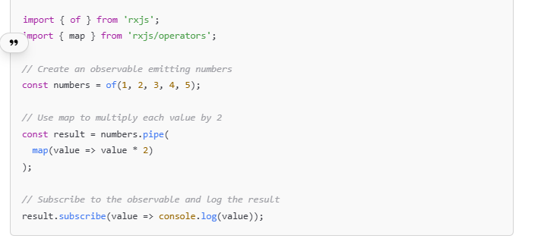
map() transforms each value emitted by the observable. In this case, each value is multiplied by 2.

2. filter() - Filtering values based on a condition
The filter() operator filters the values emitted by the observable based on a condition.
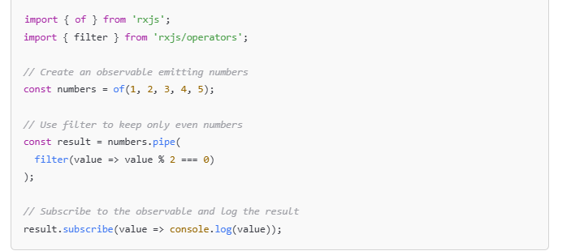

3. take() - Taking only a limited number of emissions
The take() operator limits the number of emissions from the observable. Once the specified number of emissions have been received, the observable automatically completes.
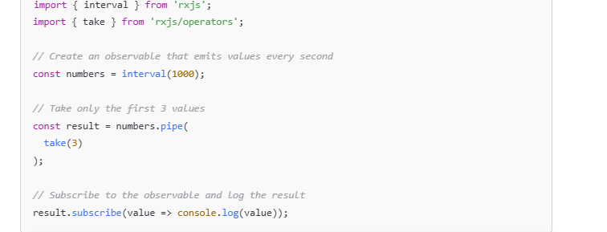

4. concatMap() - Sequential mapping (Handling inner observables)
The concatMap() operator maps each emitted value to an observable, then waits for each observable to complete before proceeding to the next.
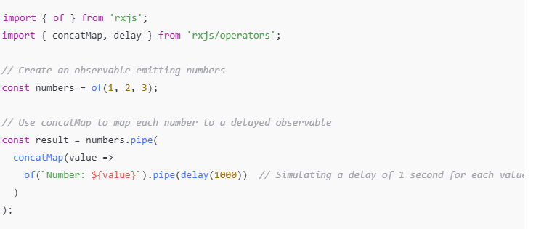

5. switchMap() - Switching to a new observable
The switchMap() operator maps an emitted value to an observable, but if a new value arrives, it cancels the previous observable and switches to the new one.

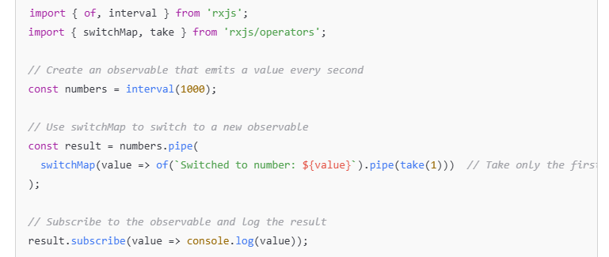

Explanation:
- switchMap() switches to a new observable each time it receives a value. It cancels the previous observable and switches to a new one.
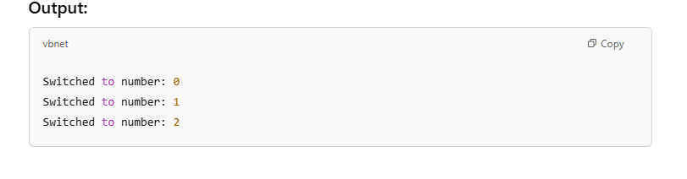

6. mergeMap() - Merging multiple observables
mergeMap() maps each emitted value to an observable, but instead of waiting for the previous observable to complete, it subscribes to all inner observables and merges their results.
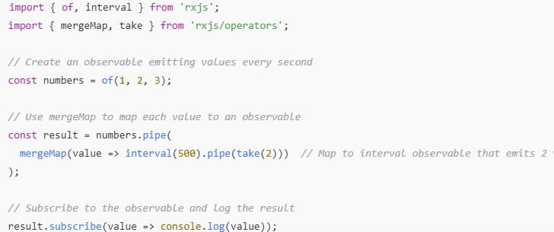

Explanation:
- mergeMap() subscribes to all inner observables and merges their results, without waiting for each to complete.
import { of } from 'rxjs';
import { retry, map } from 'rxjs/operators';

// Create an observable that emits an error
const result = of(1, 2, 3).pipe(
map(value => {
if (value === 2) {
throw new Error('Something went wrong');
}
return value;
}),
retry(2) // Retry up to 2 times before erroring out
);

// Subscribe to the observable and log the result
result.subscribe({
next: value => console.log(value),
error: err => console.log('Error:', err)
});

Explanation:
- retry(2) will automatically retry the observable 2 times if it encounters an error before giving up and emitting an error

8. debounceTime() - Delay emissions until there is a pause in the emissions
The debounceTime() operator only emits the latest value after a specified amount of time has passed without a new emission. It’s often used for scenarios like waiting for the user to stop typing in a search bar before triggering an action.
javascript
Copy
import { of } from 'rxjs';
import { debounceTime, map } from 'rxjs/operators';

// Simulating a series of rapid key presses (values emitted every 200ms)
const keypresses = of('A', 'B', 'C', 'D').pipe(
debounceTime(500), // Wait for 500ms after the last emission before emitting
map(value => `Key pressed: ${value}`)
);

// Subscribe to the observable and log the result
keypresses.subscribe(value => console.log(value));

Explanation:
- debounceTime(500) waits 500ms after the last emitted value before emitting the result. This is useful when you want to wait for the user to stop typing before triggering an action (like a search query).

Conclusion:
These are just a few of the many powerful operators available in RxJS! Each operator is designed for specific use cases, like transforming data (map), handling errors (retry), limiting emissions (take), or controlling flow (switchMap, concatMap, mergeMap).
Keep experimenting with these operators, and you’ll be able to handle complex asynchronous and event-driven programming with ease!

